CHAPTER 1
INTRODUCTION

1.1 Overview
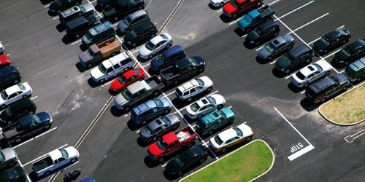
Since last 10 years, there is a huge increase in number of vehicles. But the current transportation infrastructure and car park facilities are insufficient in sustaining the influx of vehicles on the road. Therefore, problems such as traffic congestion and insufficient parking space inevitably crops up. Car parking occupancy detection are of great importance for an effective management of car parking lots. Knowing in real-time availability of free parking spaces and communicating to the users can be of great help in reducing the queues, improve scalability and the time required to find an empty space in a parking lot. Various measures have been taken in the attempts to overcome the traffic problems. Some methods like sensor-based a computer vision classifier are functional nowadays to reduce the problems regarding parking. But these systems are either very costly or less efficient and less robust.
Figure 1.1: Car parking slot
So, for these kinds of issues the researchers have developed some solutions like parking lot recognition techniques by making use of some objects like video cameras and sensors which are used to detect an empty and occupied state of the parking space. By using YOLO (You Only Look Once), which is an object detection algorithm based on Convolutional Neural Network (CNN). YOLO is refreshingly fast as well as simple and YOLO trains on full images and directly optimizes detection performance.
The aim of this is to solve the issue of car parking for some extent which is done by taking videos from surveillance cameras and detecting the occupancy of the parking slot whether the parking space is Empty or Occupied. By using this technique, the main parking lot issue, that is availability of the parking spaces in the parking lot is solved, so that the drivers do not waste much time in searching for the parking space.
The system helps to solve the parking problem. As showed in figure 1.1, traditional parking system a person has to find vacant slot or a gate keeper needs to inform about the available parking slot at parking area. To address the issue, have a system where the user will be able to know the number of vacant slots in a particular parking area along with total number of slots at the entrance of the parking area. As a critical component of this project, by building a car parking slot detection system which collects data from a camera at parking area.
Today's most popular object detection model YOLO, is trained to achieve desired results with good precision scores at real-time speed. Real time processing is performed on the obtained data by the model to find whether the slot is vacant or occupied. This paper will be using the concept of object detection in the parking area and this object detection is based on computer vision which uses camera as input at the parking area. YOLO (You Only Look Once) showed a significant breakthrough in the field of object recognition and classification. The vehicle detection based on YOLO algorithm has better result which uses Convolution Neural Network (CNN) to extract features.
Using CNN (convolutional neural network) for the object detection is to analyse the underlying feature characteristics and target objects in the images by the help of supervised learning. The algorithm of YOLO (You Only Look Once) will be improving the accuracy of obtaining target object information from the image. YOLO is an end-to-end target object detection algorithm. The algorithm transforms the problem of target object detection into a problem of regression. YOLO algorithm will be improving the object detection accuracy and efficiency. The improvements are done by adding batch normalization after every convolution layer. Performing multi-scale training and applying the K-means dimension clustering on the training set bounding box to which will be automatically determine the suitable priors.

  - YOLO
The YOLO ("you only look once") algorithm is popular because it achieves high accuracy while running in real-time. In the sense that it only requires one forward propagation pass through the network to create predictions, this method "only glances once at the image. It then outputs recognised items together with bounding boxes after non-max suppression. YOLO employs & single CNN network for both classification and bounding box localization. You Only Get One Look: Object detection that is unified and real-time.
YOLO v1
YOLOv1 is a single-stage object detection model. Object detection is framed as a regression problem to spatially separated bounding boxes and associated class probabilities. A single neural network predicts bounding boxes and class probabilities directly from full images in one evaluation. Since the whole detection pipeline is a single network, it can be optimized end-to-end directly on detection performance.
The network uses features from the entire image to predict each bounding box. It also predicts all bounding boxes across all classes for an image simultaneously. This means the network reasons globally about the full image and all the objects in the image.
YOLO v2
YOLOv2 is a deep learning algorithm that uses a single neural network to simultaneously predict bounding boxes and class probabilities for objects in an image. It has been used for fire detection by training on images and identifying features that are common to fires, such as colour and texture.
YOLOv2 can achieve high accuracy in object detection tasks and can process images in real time. It is also relatively simple to implement. YOLOv2 may struggle with detecting fires in images with complex backgrounds or in lowlight conditions. It may also require large amounts of data for training
YOLO v3
YOLOv3, an enhanced version of YOLOv2 for object detection, introduces improvements for accuracy while maintaining speed. It predicts bounding boxes using anchor box clusters and incorporates logistic regression to assign an objectiveness score for each box. It employs independent logistic classifiers instead of SoftMax for class predictions, using binary cross-entropy loss during training. YOLOv3 predicts boxes at three scales, akin to FPN, utilizing multi-scale feature extraction through a network called DarkNet53, a fusion of DarkNet19 and a novel residual network, optimized for GPU efficiency. It excels in identifying small objects due to multi-scale predictions but shows comparatively lower performance on medium and large objects.
The model's speed and precision trade-off can be adjusted by varying its size. However, its performance diminishes as IoU thresholds increase, and it struggles to align precisely with ground truth. For sonar datasets with limited samples and low signal-to-noise ratios, a refined version named YOLOv3-DPFIN. It excels in real-time detection of noise-intensive multi-category sonar objects underwater, achieving higher precision and speed than the original YOLOv3 model.
YOLO v4
YOLO (You Only Look Once) v4 is a state-of-the-art object detection model, renowned for its speed and accuracy in real-time object detection tasks. It is part of the YOLO series, which revolutionized object detection by introducing a single-stage object detection architecture. YOLO v4 is an advancement over its predecessors, aiming to improve accuracy while maintaining impressive real-time performance.
Developed by a team of researchers, YOLO v4 integrates various improvements in architecture design, training techniques, and model optimization to enhance object detection capabilities across different domains. It incorporates features like a more robust backbone network, advanced data augmentation strategies, and innovative training methods to improve detection accuracy, especially for small and challenging objects. YOLO v4 maintains the core principles of its predecessors: high-speed inference and accurate bounding box predictions for multiple objects within an image. This model has garnered attention for its ability to handle real-time object detection tasks efficiently, making it a popular choice in applications like autonomous driving, surveillance, robotics, and more.
YOLO v5
YOLO v5 represents the latest evolution in the renowned YOLO (You Only Look Once) series for object detection. Developed by Ultralytics, this iteration focuses on refining and enhancing the core principles of real-time object detection. It introduces a streamlined convolutional neural network architecture that prioritizes speed and accuracy. YOLO v5 offers different model variants—varying in size from YOLOv5s to YOLOv5x—allowing users to choose models based on their specific trade-offs between model size, speed, and accuracy. Notably, its user-friendly nature simplifies the setup, configuration, and training processes, making it accessible for a broad range of applications such as autonomous vehicles, surveillance systems, robotics, and more, where rapid and precise object detection is pivotal. Overall, YOLO v5 is a significant leap forward in object detection, appreciated for its improved performance, efficiency, and ease of use within the computer vision community.
YOLO v6
YOLOv6, an evolution of the popular You Only Look Once (YOLO) object detection algorithm series, builds upon its predecessors' strengths of speed and accuracy. With enhancements in its architecture, potentially leveraging different backbone networks like CSP Darknet or YOLOv5's design, YOLOv6 aims to improve object detection performance while maintaining real-time processing capabilities. It might introduce novel training strategies and optimization techniques to enhance model generalization and adaptability to diverse datasets. YOLOv6 strives to be user-friendly, offering efficient deployment options for applications like real-time object detection in videos, surveillance systems, autonomous vehicles, and more. For the most recent and detailed information about YOLOv6, consulting the latest research publications and official resources is recommended.
YOLO v7
YOLO (You Only Look Once) v7 stands as the seventh iteration of the groundbreaking object detection algorithm. Renowned for its real-time detection capabilities, YOLO revolutionized the field by processing images in a single pass through the neural network, swiftly identifying multiple objects within a single frame. This approach, dividing the image into a grid and predicting bounding boxes and class probabilities for each grid cell, allows for simultaneous object detection. YOLO v7 maintains the balance between accuracy and speed, leveraging advanced backbone architectures for feature extraction, thereby enhancing its ability to comprehend complex visual patterns. Continuously evolving, each version of YOLO aims to refine object detection performance by integrating novel techniques and architectural improvements into its framework.
YOLO v8
YOLO v8, the latest iteration of the YOLO (You Only Look Once) series. YOLOv8 represents a significant milestone in computer vision, designed to enhance the efficiency and precision of object detection. Its underlying principle simplifies the process by processing an entire image through a neural network known as a convolutional neural network (CNN) in a single pass, eliminating the need for laboriously inspecting each part of the image individually. This streamlined approach, often referred to as “You Only Look Once,” leads to impressive gains in both speed and efficiency.
- Principle followed by YOLO v8
YOLOv8 follows a straightforward set of principles. It all starts with an input image, which can be of varying sizes, making it a versatile tool for a wide range of applications. The image then undergoes a process of feature extraction within a neural network. This network, carefully engineered and trained, excels at identifying and highlighting the most relevant features within the image, akin to a detective piecing together crucial clues at a crime scene. YOLOv8 stands out by not just detecting objects at a single scale but by simultaneously spotting them at different scales, ensuring it can identify objects both large and small effectively.
- The Role of Anchor Boxes in YOLO v8
Key to YOLOv8’s prowess in object detection is its utilization of anchor boxes. These anchor boxes act as predefined templates for various objects, aiding the algorithm in making informed predictions about object locations and sizes within specific grid cells. By leveraging anchor boxes, YOLOv8 enhances its accuracy and precision, further bolstering its ability to recognize objects in images accurately. It’s akin to having a set of standardized models that help YOLOv8 determine the shape and size of the objects it encounters, contributing to more accurate predictions.
- YOLOv8’s Advancements Over Previous Versions
When compare YOLOv8 with its predecessors, it becomes evident that it brings significant advancements to the table. It combines the speed and efficiency that were hallmarks of earlier YOLO versions with improved accuracy and adaptability. YOLOv8’s ability to handle various input sizes and its array of specialized variants cater to a broad spectrum of real-world applications, from real-time tasks on resource-constrained devices to challenging scenarios involving blurred images or intricate datasets. Its enhanced generalization, fewer false positives, and improved non-maximum suppression techniques further underline its reliability in practical use cases. As computer vision continues to evolve, YOLOv8 serves as a testament to the ongoing quest for more refined, faster, and more precise object detection algorithms, with the potential to revolutionize industries such as autonomous vehicles, healthcare, and beyond. In conclusion, YOLOv8 is a monumental step forward in the realm of object detection, symbolizing the relentless pursuit of better solutions in the exciting field of computer vision.

  - Literature Survey
Bandi Sairam and Gopi Krishna [1] from the department of Information Technology National Institute of Technology, Raipur, India, presented research on Automated Vehicle Parking Slot Detection System Using Deep Learning. This method focuses on the use of Mask R CNN architecture for solving instance segmentation problems in deep learning. Specifically, it discusses how the model is used to detect objects in images, provide their bounding boxes and classes, and create a mask around the objects. Additionally, the use of PSDL (Parking Slot Detection System) for detecting marking points, determining the type of parking slot, and identifying free space between vehicles using sensors. This combination of technologies aims to address automated vehicle parking slot detection.
The implementations discussed revolve around utilizing vision-based car parking technology, particularly in the context of detecting parking slots using web cameras. It emphasizes the challenges and cost considerations associated with sensor-based slot detection systems and highlights the preparation and maintenance of infrastructure as a major concern.
The conclusion focuses on the successful implementation of the Mask R CNN method, achieving significant accuracy in recognizing object masks and detecting object bounding boxes. Additionally, it emphasizes the simulation-based nature of the method used, as well as the cost considerations and infrastructure maintenance concerns associated with sensor-based slot detection systems. The approach specifically focuses on vision-based car parking, leveraging web cameras for slot detection, and provides insights into the accuracy and practical implications of the method.
Raj Patel and Praveen Meduri [2] from the department of Computer Engineering, California State University Sacramento, USA, presented research on Car Detection Based Algorithm for Automatic Parking Space Detection. This method focuses on a car detection-based algorithm for automatic parking space mapping and detection. It discusses an approach that aims to achieve a high level of automation in mapping parking lots, with a particular emphasis on detecting parked cars and available parking spaces. The approach is designed to have its highest performance over a busy parking lot during the busiest time, indicating its practical application in real-world scenarios.
The methodology presented in the method focuses on an approach for automatic parking space and car detection. It takes advantage of the fact that parked cars tend to remain stationary for longer periods. The approach is designed to significantly reduce the human effort involved in mapping parking lots, with results indicating a compelling 90% reduction. One of the strengths of this approach is that the recall of the parking space detection scheme increases with the number of parked cars, and in theory, it could approach 100% detection on a day when all parking spots are fully occupied. It also emphasizes the generalizability of the approach across different parking lots and camera angles, attributing its success to its focus on car features rather than parking lot features.
The implementation details specifies where the performance of the approach is evaluated. It discusses the selection of threshold values for parameters such as the IoU and the frame rate, which are crucial in determining the accuracy of the car tracking approach. Notably, it highlights that while these hyperparameters require tuning, they only marginally reduce accuracy when within a reasonable range.
Thus, it concludes the method's ability to effectively identify a significant number of parking spaces is highlighted. It emphasizes the approach's potential to greatly reduce the human effort involved in mapping parking lots, leading to a compelling 90% reduction. Moreover, the paper discusses the theoretical capability of the approach to achieve close to 100% detection of all parking spots on days when the parking lot is fully occupied. It emphasized the approach's consistent performance across different parking lots and camera angles, attributing this to the focus on car features rather than parking lot features. The ability of the approach to detect parking spaces even with faint parking lines is also underscored.
Moran JU and Haibo LUO [3] from the department of Institutes for Robotics and Intelligent Manufacturing, Chinese, presented research on A Simple and Efficient Network for Small Target Detection. This uses ‘‘dilated module’’ to expand the receptive field without loss of resolution or coverage. Then the applied feature fusion in different dilated modules to improve the ability of the network in detecting small targets. Finally, used ‘‘passthrough module’’ to get the finer-grained information from the earlier layer and combined it with the semantic information from the deeper layer. To improve the detection speed of the network, it uses 1 × 1 convolution to reduce the dimension of the network. The composed small vehicle dataset based on VEDAI dataset and DOTA dataset, respectively, and also analysed the distribution of the small targets in each dataset. To evaluate the performance of the network, trained the model on the dataset above and compared with the state-of-the-art target detection algorithms. The method utilizes several key techniques to improve small target detection. The use of dilated modules to expand the receptive field, passthrough modules to combine fine-grained and semantic information, and feature fusion all contribute to enhancing the network's ability to detect small targets. Additionally, the method incorporates 1x1 convolutions to reduce the dimension of the network, resulting in reduced computation and improved detection speed.
The conclusion emphasizes a simple, fast, and efficient network designed for small target detection. The network's effectiveness is highlighted through quantitative and qualitative comparisons with state-of-the-art networks. It is noted that the method improves the ability to detect small targets and accurately locate them. The authors detail the use of dilated modules to expand the receptive field, the implementation of feature fusion, and the utilization of passthrough modules to enhance the network's performance.
Hanbo Zhoua and Wei Xiangc [4] from the department of Southwest Minzu University, China, presented research on Method for judging parking status based on yolov2 target detection algorithm. The method focuses on based machine vision to distinguish parking spaces. This method uses the yolov2 target detection algorithm, uses the camera to collect the image information of the parking spaces and vehicles, uses the yolov2 target detection algorithm to build the vehicle and parking space contour detection model, and obtains the parking space and vehicle center coordinate information, and calculates the vehicle and parking space contours through the parking space discrimination algorithm To determine whether there is a vehicle parked in the parking space, determine the status of the parking space (occupied/vacant).The experiment outlines a methodology for judging parking status based on the YOLOv2 target detection algorithm. The method based on machine vision to distinguish parking spaces and effectively utilize public parking space resources on the roadside, aiming to realize smart transportation more comprehensively.
Afterwords, the experiment was conducted. Firstly, they collected more than 600 pictures of moving and stationary vehicles during both day and night using a drone. These images were then used to establish a vehicle contour recognition model. The dataset was divided into a training set and a test set in an 8:2 ratio. To enhance the precision and accuracy of the dataset, data augmentation techniques were employed. This involved flipping the pictures, zooming in on the partial dataset, and simulating various complex environments. The experiment involved data collection, dataset division, data augmentation, and the application of the YOLOv2 algorithm for parking space identification and vehicle center coordinate extraction, ultimately leading to the determination of parking space status.
Aakash K. Shetty and Yashkumar J. Patel [5] from the department of Computer Engineering, NMIMS University Mumbai, India, presented research on A Review: Object Detection Models. This method focuses on comparative analysis of different object detection techniques such as R-CNN, Fast R-CNN, Faster R-CNN, YOLOv1, YOLOv2, YOLOv3, YOLOv4, and SSD. It addresses the challenges in comparing these methods, highlighting the trade-off between precision and speed for real-life applications. Furthermore, discusses the use of data augmentation to increase image variability, thereby enhancing the robustness of the models in various environments. It also touches upon optimizing the training method to achieve greater precision without increasing the cost of inference.
The methodology involves a comparative analysis of different object detection techniques, including two-stage models such as R-CNN, Fast R-CNN, and Faster R-CNN, as well as single-stage models like YOLOv1, YOLOv2, YOLOv3, YOLOv4, and SSD. The comparison focuses on parameters such as precision, backbone, accuracy, frames per second (FPS) provided, and computational time. It deduces various conclusions based on the results obtained from the comparative analysis of different object detection techniques. It emphasizes that each algorithm is equally good for its application, and the selection of a specific algorithm should align with the application model. Furthermore, It highlights the importance of exploring existing techniques, performing comparative analyses, and suggesting potential implementations for optimal results in different sectors. It also indicates that the experimental results showed single-stage object detection techniques to be more optimal compared to two-stage object detection techniques.
Cui Gao and Qiang Cai [6] from National Engineering Laboratory for Agri-product Quality Traceability, Beijing Technology and Business University Beijing Key Laboratory of Big Data Technology, BTBU Beijing Technology and Business University Beijing, China, presents research on YOLOv4 Object Detection Algorithm with Efficient Channel Attention Mechanism. This method focuses on various advanced techniques and algorithms related to object detection, attention mechanisms, and deep learning. Specifically, it discusses object detection using Yolov4 target detection algorithm, attention mechanism, and the application of these techniques in the field of deep learning for areas such as image recognition and processing. It seems to delve into the intricacies of these methods and their significance in computer vision and artificial intelligence.
The comprehensive methodology used in method, likely in the context of evaluating the effectiveness of object detection and attention mechanisms in deep learning. It mentions the use of the Yolov4 target detection algorithm, attention mechanisms, and the measurement of various parameters such as mAP (mean Average Precision) and detection speed. The methodology also appears to involve a comparative analysis with other works, potentially aiming to highlight the significance of the techniques.
It concludes that, an improved YOLOv4 object detection algorithm, attention-Yolov4, with the efficient channel Attention mechanism. This algorithm can improve the accuracy at a relatively low additional computational cost. The algorithm introduced channel attention mechanism ECANet into the residual module of YOLOv4's backbone network, CSPDarknet53, and added different weights to the channel features to make the network pay more attention to the important features containing the object to be detected, while suppressing the invalid features affecting the final detection results, thus enhancing the robustness of the algorithm. Through experimental comparison, the detection accuracy of this algorithm has been improved to some extent.
Se-Ho Park and Hyoseok Yoon [7] from the department of Korea Electronics Technology Institute, Mapo-gu, Seoul, Korea, presented research on An All-in-One Vehicle Type and License Plate Recognition System Using YOLOv4. The development of an innovative system that addresses Korean License Plate Recognition (LPR) with vehicle type detection, showcasing its potential for various complex smart city applications. It also highlights the involvement of multiple authors in the conceptualization, methodology, software, validation, and other aspects of the research.
The methodology utilized involves an in-depth approach to address Korean License Plate Recognition (LPR) with vehicle type detection. The authors' contributions include various aspects such as conceptualization, methodology, software, validation, formal analysis, data curation, as well as writing and preparation of the original draft. The research also involved the development of an integrated embedded platform and a commercial prototype equipped with high-speed LPR function, demonstrating the comprehensive nature of the study.
The implementation involves the use of YOLOv4 as the underlying object detector to realize the Korean License Plate Recognition (LPR) system with vehicle type detection. The researchers utilized an open source darknet framework to train YOLOv4 for the detection of custom classes including vehicle types, license plates, and license plate characters. This approach demonstrates the utilization of deep learning technology to address the identification of various targets in smart surveillance and urban mobility applications.
Jingyi Zhao, Zhanlin JI (Member, IEEE) and Ivan Ganchev (Senior Member, IEEE) [8] from department of Telecommunications Research Centre (TRC), University of Limerick, V94 T9PX Limerick, Ireland presented research on Improved Vision-Based Vehicle Detection and Classification by Optimized YOLOv4. In this method, an attention mechanism is utilized to suppress the interference features of images through both channel dimension and spatial dimension. In addition, a modification of the Feature Pyramid Network (FPN) part of the Path Aggregation Network (PAN), utilized by YOLOv4, is applied in order to enhance further the effective features through down-sampling. This way, the objects can be steadily positioned in the 3D space and the object detection and classification performance of the model can be improved.
Object detection and classification are crucial for intelligent transportation systems and various other applications. Existing object detection methods can be categorized as hardware-based and vision-based methods. Traditional feature-based object detection methods have been replaced by deep learning (DL) feature-based methods. Current DL feature-based methods are considered state of the art due to their object detection accuracy and operational speed. Many object detection models are based on CNNs due to their rich representation power. Recent advances in object detection have been driven by the success of R CNNs and other incarnations. The YOLOv4_AF model utilizes an attention mechanism to suppress interference features of images and enhances effective features through down sampling. Experiments demonstrate that YOLOv4_AF outperforms the original YOLOv4 model and other state-of-the-art models in terms of mean average precision (mAP) and F1 score. In this, a more precise vehicle detection and classification model, based on YOLOv4 with applied additional optimization, has been presented. The main idea, incorporated into it, was to increase the receptive field in both channel and spatial dimensions by introducing an attention mechanism in the form of a CBAM module.
Guan Sheng Wong and Aznul Qalid Md. Sabri [9] from department of Computer Science and Information Technology, University of Malaya, presented research paper on Review of Vision-Based Deep Learning Parking Slot Detection on Surround View Images. They explore the vision-based deep learning methods for parking slot detection. They categorize these methods into four main categories: object detection, image segmentation, regression, and graph neural network, and provide detailed explanations and insights into the unique features and strengths of each category. Additionally, they analyse the performance of these methods using three widely used datasets: the Tongji Parking-slot Dataset 2.0 (ps 2.0), Sejong National University (SNU) dataset, and panoramic surround view (PSV) dataset, which have played a crucial role in assessing advancements in parking slot detection.
The datasets mentioned include PS, PSV, and SNU with details on resolution, camera view, and the number of images for training, validation, and testing. Additionally, the document highlights the ps 2.0 dataset as widely used in the field of parking slot detection, featuring a diverse range of parking lot environments and three distinct parking lot types. The document highlights the utilization of various datasets for evaluation and talks about the methods used to generalize effectively across different datasets. Additionally, it references the exploration of techniques to reduce the model's FLOPS during inference and leveraging embedded systems specifically designed for running deep learning models. The findings in the document offer valuable insights for researchers and practitioners in this field, guiding future research directions and advancements in vision-based parking slot detection using deep learning techniques.
The conclusion, provides a comprehensive overview of vision-based deep learning approaches for parking slot detection on surround view images. It specifically focuses on deep learning methods and categorizes them into four main categories: object detection, image segmentation, regression, and graph neural network. Each category is thoroughly explained and reviewed, highlighting the key features and specialties of the methods.
Upendra Suddamalla and Balaji Ravichandiran [10] from MooVita Pte. Ltd., Singapore presented research on Camera Based Parking Slot Detection For Autonomous Parking. This method using a novel combination of computer vision techniques on the camera data mounted on sides of a car. Autonomous driving and driver assistance systems are emerging areas to enhance human safety and driving experience. Autonomous parking requires understanding the parking slot position, dimension, and occupancy status, achieved through various sensors such as Lidars, ultrasonic range detectors, radars, and cameras. The Existing techniques using sensors have limitations in providing accurate markings and boundaries of parking slots, particularly when no reference object is available. Camera-based methods have been but face challenges with varying parking conditions, illumination, and noise. The method addresses the need for a generic approach to handle dynamic parking environments and random obstacles.
The conclusion focuses the effectiveness of the algorithm in addressing the problem of free parking slot detection. The algorithm is capable of detecting both cars and trees present in the input image, demonstrating its robustness in real-world scenarios. Additionally, it is noted that there is no standard public dataset available for the problem of interest, emphasizing the significance of the dataset collected for the research. The complete system of the algorithm has been depicted as a flow diagram to illustrate its functionality.
Fatma M. Talaat and Hanaa Zain Eldin [11] from the department of Computers and Control Systems Engineering, Faculty of Engineering, Mansoura University, Egypt, presented research on An improved fire detection approach based on YOLO-v8 for smart cities. This improved fire detection approach for smart cities based on the YOLOv8 algorithm, called the smart fire detection system (SFDS), which leverages the strengths of deep learning to detect fire-specific features in real time. The SFDS approach has the potential to improve the accuracy of fire detection, reduce false alarms, and be cost-effective compared to traditional fire detection methods. It can also be extended to detect other objects of interest in smart cities, such as gas leaks or flooding. The framework for a smart city consists of four primary layers: Application layer, Fog layer, Cloud layer, and IoT layer. The algorithm utilizes Fog and Cloud computing, along with the IoT layer, to collect and process data in real time, enabling faster response times and reducing the risk of damage to property and human life.
The conclusions are evident that the system has made a valuable contribution to the field of computer vision and real-time fire detection. The system also seems to have potential for further improvement and application in real-world scenarios. The possibility of using OCNN and correlation methods in the future work to achieve better results. Additionally, the document emphasizes the importance of a secure and open access infrastructure, user-centered architecture, and the capability to store, retrieve, share, and access a vast amount of public and private data.
Nabin Sharma and Rathachai Chawuthai [12] from Department of Computer Engineering, School of Engineering, King Mongkut’s Institute of Technology Ladkrabang, Bangkok, Thailand, presented research on Parking Time Violation Tracking Using YOLOv8 and Tracking Algorithms. This presents an approach that can introduce a low-cost time violation tracking system using CCTV, Deep Learning models, and object tracking algorithms. This approach is fairly new because of its appliance of the SOTA detection technique, object tracking approach, and time boundary implementations. YOLOv8, along with the Deep SORT/OC-SORT algorithm, is utilized for the detection and tracking that allows us to set a timer and track the time violation. Using the same apparatus along with Deep Learning models and algorithms has produced a better system with better performance. Also introduces a real-time parking time violation tracking algorithm using closed-circuit cameras and DL models with a tracking algorithm to persist the information from one frame to its subsequent frame. The algorithm utilizes a state-of-the-art object detection algorithm called YOLOv8 for detecting vehicles. For tracking vehicles, two object tracking algorithms were implemented, Deep SORT (Simple Online Real Tracking) and Observation Centric SORT (OC-SORT).
The conclusion mainly highlights the effectiveness and significance of the algorithm for parking violation detection in a time series context, citing its accurate and reliable solution to the parking time violation problem. It acknowledges the innovative approach, emphasizing the exploration of state-of-the-art object detection and tracking models, and the novel frame-by-frame evaluation with respect to time. Additionally, the conclusion includes a review of related work, details of the parking time violation process, and the presentation of results.
Xiangwu Ding and Ruidi Yang [13] from Donghua University, shanghai, shanghai, China presented research on Vehicle and Parking Space Detection Based on Improved YOLO Network Model. This is based on YOLO v3 network and applied to parking spaces and vehicle detection in parking lots. Based on YOLO v3, this adds a residual structure to extract deep vehicle parking space features, and uses four different scale feature maps for object detection, so that deep networks can extract more fine-grained features. Experiment results show that this method can improve the detection accuracy of vehicle and parking space, while reducing the missed detection rate. The current research dataset comes from three datasets, the PASCAL VOC dataset, the COCO dataset, and the PKLot dataset. The PASCAL VOC and COCO data sets are common data sets for object detection, with 20 categories and 80 categories respectively. This experiment only uses the three data sets car, bus, and truck. The PKLot dataset provides an image dataset for parking space classification. The PKLot dataset is not the format of the PASCAL VOC dataset.
The improved YOLO v3 algorithm model is based on the feature pyramid network structure, and the feature maps of different levels are merged and connected to obtain four sets of predicted feature maps, and the position and class predictions are performed on the four sets of predicted feature maps. This mainly studies the problem of parking space detection. The vehicle and parking space detection method based on the improved YOLO v3 algorithm. The improved algorithm is applied to vehicle and parking space detection and it has achieved good results.
Daniel Padilla Carrasco and Domènec Puig [14] from department of Electronic and Communications Technology, Universidad Autónoma de Madrid, Spain, presented research on T-YOLO: Tiny Vehicle Detection Based on YOLO and Multi-Scale Convolutional Neural Networks. In this, the model can detect large, small, and tiny objects. Specifically, the use of a multi-scale mechanism to learn deep discriminative feature representations at different scales and automatically determine the most suitable scales for detecting objects in a scene (i.e., in case vehicles). The multi-scale module reduces the number of trainable parameters compared to the original YOLO-v5 architecture. The experimental results also demonstrate that precision is improved by a large margin. The PKLot1 dataset, structured based on parking locations, meteorological states, and specific days, contains approximately 4474 images with almost 100 tagged parking spots. These images include the location of bounding boxes and occupancy, totalling around 424,269 tagged spots. The dataset was split into 80% for training and 20% for testing. The model was implemented using a system comprising a GPU of Nvidia 2080 Ti and the PyTorch library. The YOLOv5 baseline was used, employing hyperparameters and configurations consistent with YOLOv5. The model was validated on the PKLot dataset, utilizing both a COCO-trained YOLOv5 model and a PKLot fine-tuned YOLOv5 model. It also mentions the introduction of a new layer in YOLOv5 that resulted in a significant outperformance of the baseline model. Additionally, the impact of spatial and channel information using attention modules on the performance of tiny object detection is discussed.
Mamoona Humayun and Marwah Khalid Alsadun [15] from the department of Information Systems and Department of Computer Science, College of Computer and Information Sciences, Jouf University, Saudi Arabia, presented research on Traffic Management: Multi-Scale Vehicle Detection in Varying Weather Conditions Using YOLOv4 and Spatial Pyramid Pooling Network. This focuses on the development and application of a methodology for object detection in traffic scenarios using the DAWN dataset, a collection of 1000 photos from actual traffic scenarios. The data annotation process, which involves labeling images in YOLO_Darknet format using a free and open-source tool called Label Image. They also mention the necessity of adaptive data fusion in infrastructure augmented autonomous driving systems in a brief. This suggests a focus on advanced technologies for autonomous driving systems.
The methodology used involves the development and application of a methodology for object detection in traffic scenarios using the DAWN dataset, which consists of 1000 photos from actual traffic scenarios. The researchers discuss the data annotation process, utilizing the YOLO_Darknet format and the open-source tool LabelImg for labeling images. Additionally, it mentions an extension of the vehicle detection algorithm for vehicle trajectory analysis, where vehicle location, speed, acceleration, and jerk are used as time functions to detect normal and abnormal vehicle motion patterns. Furthermore, it includes image augmentation techniques related to specific weather conditions.
The implementation details are focused on the use of the DAWN dataset, which contains 1000 photos from real traffic scenarios, to train the model. The data annotation process involved labeling images in YOLO_Darknet format using the open-source tool LabelImg. Additionally, it discusses an extension of the vehicle detection algorithm for vehicle trajectory analysis, utilizing vehicle location, speed, acceleration, and jerk as time functions to detect normal and abnormal vehicle motion patterns using a video dataset.
  - Problem Statement
As the population grows, there is an increase in the private vehicles which caused many issues to the people at the crowded areas such as shopping malls, restaurants and universities parking lots. This results in time waste for the drivers in search for the empty parking space which includes atmospheric pollution and frustration of the drivers. Developing a project that uses a camera to record real-time data and feed it to a system to discover vacant car parking slots in a parking area. Car parking slot detection using YOLO algorithm which calculates the number of vacant parking slots in a parking area based on the system's confidence level.
  - Objectives
- To design a model that can efficiently detect the Empty and Occupied status of the parking space in an image and a video by making use of YOLO object detection.
- To import an image from a webcam and performing the operations in the system.
- To identify moving objects with high accuracy.
- To provide information about vacant parking space in real time with efficient manner.
- To avoid traffic congestion in parking space.

  - Scope
- Smart Parking Systems: YOLO-based parking spot detection can be used to create smart parking systems that can automatically detect and inform drivers about available parking spaces in real-time. This helps reduce traffic congestion and save time for drivers looking for parking spots.
- Parking Guidance Systems: By integrating YOLO-based parking spot detection with guidance systems, drivers can be directed to the nearest available parking spot, optimizing parking space usage and improving overall traffic flow.
- Parking Violation Detection: YOLO can be used to detect vehicles that are parked illegally or have exceeded their parking time limit, enabling automated enforcement of parking rules and regulations.
- Urban Planning: Data collected from YOLO-based parking spot detection can be used by urban planners to analyze parking patterns and make informed decisions about parking space allocation and future infrastructure development.

  - Organization of Report
The report consists of 5 chapters. In chapter 1, the overview of car parking slot detection, introduction to YOLO algorithm, brief description of fifteen different papers that are studied during the literature survey, problem statement, objectives and scope. In chapter 2, domain specification is explained. In chapter 3, system design and implementation are explained and chapter 4 contains the final results and analysis carried during the project. In chapter 5, the conclusion and future scope is given in the last chapter.
CHAPTER 2
DOMAIN SPECIFICATION
2.1 Existing System
Due to the daily rise in car traffic, manually finding parking spaces has become a significant problem for modern urban mobility. If there are any open parking spaces, one must physically inspect the parking area. Some parking slots adopt a token system that causes traffic jams because it takes time to create the tokens and someone has to give them out. The usual approach or traditional system is manually locating parking spaces is difficult and time- consuming to address this, have presented this initiative. Three algorithms are trained for object detection: SSD (Single shot Detector), Faster RCNN, and YOLOv2. YOLOv2 performs better when the results of Faster RCNN, SSD, and analysis are compared. YOLO (you only look once) is six times faster than Faster CNN.

2.1.1 Drawbacks
- SSD does worse for smaller objects as it may not generate enough high-level features to do prediction for small objects.
- SSD needs a large number of data to train.
- Faster RCNN does not meet the real time requirement of object detection
- To detect object YOLO uses single forward propagation while Faster RCNN uses multiple iteration of same image.

2.2 Proposed System
One of the biggest issues that the modern society is currently dealing with is how to handle the practical problem of finding parking spaces. It is preferable to utilize a camera that is placed far away to monitor a large parking area or parking lot, allowing for the monitoring of the entire space. The suggested YOLO model gathers all initially available parking spaces in the specified area, and real-time processing is done on the data collected to determine if the spaces are empty or occupied by any vehicles, and provides the information of empty slots.

In this project first, must initially the training model by drawing the square box. If the car is parked in that specified square box where it must be parked, the YOLOv2 will detect it. the identification of available slots is based on a threshold value, from which the YOLOv2 will detect the free slots is available or not. The result will provide the total number of available slots divided by the total number of slots in that parking, so the user or driver may determine whether there are slots available to park their car.

2.2.1 Advantages
- In the car parking management system, which is used to detect vacant parking slots, one factor that has to be considered is the cost required. This system is a cost-effective car parking management system that detects vacant parking slots using cameras instead of sensors.
- YOLOv2 detect car in one glance and the detection will loop over 10 seconds. And output will be updated every 10 seconds.
- By employing ‘‘You Only Look Once version 2’’ (YOLO) architectures as baseline detectors, due to their speed, low propagation latency, straightforward architecture, and high accuracy in general object detection tasks.
- Convolutional neural network offers the best performance for object detection and recognition in images.
- YOLOv2 architectures proven to be fast and accurate one-stage detectors and capable of large-scale detections.

2.3 Requirements Specification
2.3.1 Functional Requirements
- Load the trained model: Marking the parking slots present in the parking area image to train the model. Load that image to the system which will act as trained model.
- Give video as input: Providing the live video of parking area from the camera to the system as input.
- Get the total parking slots: The system will analyse the input with the trained model and learn from it. Thus get the total parking slots present in the parking area.
- Calculate the vacant parking slots: The system will calculate the number of vacant slots present in the parking area by its confidence score.

2.3.2 Non-Functional Requirements
- Performance Requirement: The system must be spontaneous and work in real time to give accurate outcomes from the application. So that the user can get complete usage of the application effectively and efficiently.
- Security Requirements: The application program must be secured from unauthorized accesses. Only the authorized owner should have the access to bring changes in the application program.
- Maintainability: Maintainability of a software system include checking the performance of the application and updating or upscaling the application as per the requirement.
- Reliability and Availability: The system must be reliable in giving proper analysis and securing details. The application must be available to perform operations in all kinds of situations.
- Adaptability and Usability: The application must be user friendly, can able to understand by a non-technical person also.

2.3.3 Hardware Requirements
- Processor: intel core i5
- Hard disk: 250Gb
- Ram size: 4Gb
- Processor speed: 2.5GHz
- Camera: 2 megapixel or more

2.3.4 Software Requirements
- Scripting language: Python 3.5 or 3.6
- Libraries: cv2, numpy, pickle, cvZone
- Software: Pycharm

2.4 Summary
In this chapter, domain specification of this project is explained. The existing system and its drawback, proposed system and its advantages, its requirement specifications are explained.
CHAPTER 3

SYSTEM DESIGN AND IMPLEMENTATION
3.1 System Design
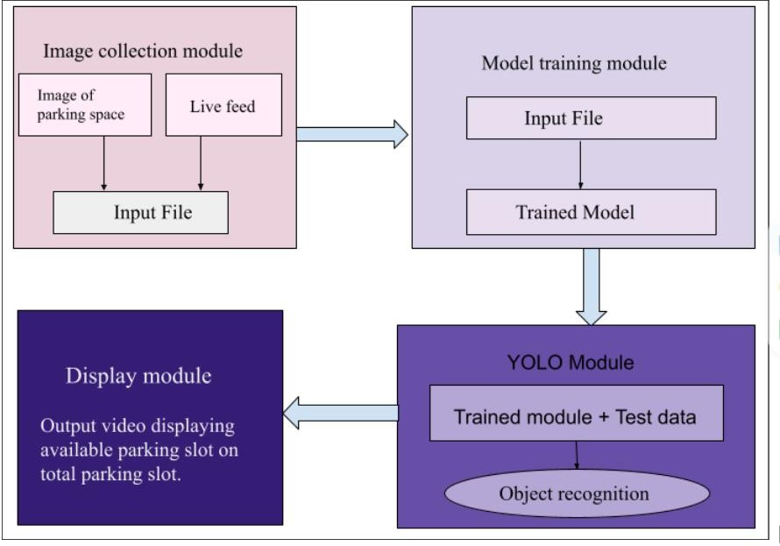
System design is the conceptual design that defines the structure and behaviour of a system. A design description is a formal description of a system, organized in a way that supports reasoning about the structural properties of the system. It defines the system components or building blocks and provides a plan from which products can be procured, and systems developed, that will work together to implement the overall system.

Figure 3.1: System modules
The method of performing the project is described. To meet the requirements, have defined the modules, components, interfaces and data for the system. In this system, the working is distributed among 4 modules as showed in figure 3.1. The 4 modules are,
- Image Collection Module
- Model Training Module
- YOLO Module
- Display Module
- Image Collection Module: Data is the most necessary component in any project. Based on the project the data can be of any form such as image, video, text etc. Large amount of data is required to develop a strong model. Image of parking slot and live video together is used as input and is fed to the training model to train the module. The img.read method is used to read data. The cvzone package is a computer vision package that makes it easy to run Image processing. It uses OpenCV, an open-source library to achieve computer vision tasks and to process images.
- Model training Module: Input image is divided into SxS grids. If the object which has to be detected is in the centre of the grid cell, then the location information of that object is predicted by that cell. A cell predicts the conditional probability of categories C, bounding boxes B and their confidence scores. Each bounding box will be predicting the information, which includes coordinates (x, y), width w and height h of the target object and the confidence score, which are recorded as tx, ty, tw, th respectively. The confidence score of each box helps to decide if a box has the object. Boundary is drawn around each parking slot. Initially the parking space slot is a colour image, the model will change that area to gray colour to detect the occupancy. The trained model is passed to the YOLO module.
- YOLO Module: YOLO is an object detection algorithm that divides an image into a grid and predicts bounding boxes and class probabilities for each grid cell. YOLO can identify and locate multiple objects within an image. In the case of parking slot detection, it's trained to recognize empty and occupied parking spaces.
- Object Detection
YOLO processes the input images or video frames and detects parking slots by drawing bounding boxes around the identified slots. The algorithm also assigns number of slots being empty.
- Decision Making
Once the YOLO algorithm identifies parking slots, the vacant slots bounding box coloured in green and the occupied slot are coloured in red.
- Display Module: Trained model is used to detect vacant space. The img.show method is used to display the output video, which also contains the vacant parking slot numbers calculated by this model. If the confidence value for any parking spot is greater than a certain threshold, it will consider that parking slot as occupied. The available parking space is calculated by subtracting the total available parking slot from occupied parking slots. Occupied slots are initialized with red boxes, vacant slots with green. As a car leaves a space, the red box turns green. Car drives into a free space, the green box turns red. The confidence score changes while a car enters or leaves the parking slot.
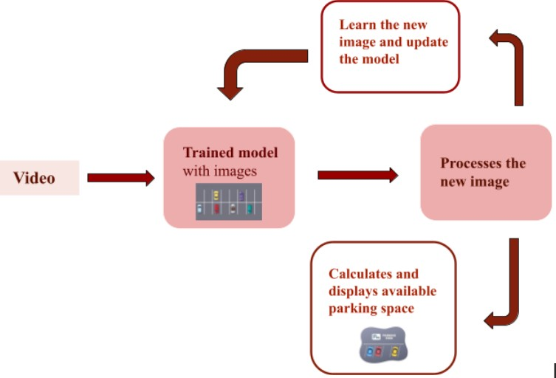
3.1.1 Design Overview

Figure 3.2: System Design
- The system model is trained using an image of a parking area in which must draw boxes around the slots in order to train it.
- As showed in figure 3.2, model receives live video from the parking area as input.
- The model takes frames from the input video, and each image frame is partitioned into a SxS grid which will be responsible for detecting an object.
- Each grid cell predicts bounding boxes and confidence scores for object detection.
- Based on the confidence score of each slot, the system will predict whether the slot is occupied or vacant.
- Number of vacant slots along with the total number of parking slots present in the parking system is displayed as output by the system.
3.2 Implementation
3.2.1 Main Packages
The main packages used in car parking slot detection system are described in table 3.1.
Table 3.1: Packages
Packages | Description
cv2 | cv2 is the module import name for OpenCV python, "Unofficial pre-built CPU-only OpenCV packages for Python". The traditional OpenCV has many complicated steps involving building the module from scratch, which is unnecessary.
pickle | Python pickle module is used for serializing and de-serializing python object structures. The process to converts any kind of python objects (list, dict, etc.) into byte streams (0s and 1s) is called pickling or serialization or flattening or marshalling.
cvzone | This is a computer vision package that makes it easy to run Image processing and AI functions.
numpy | NumPy stands for Numerical Python or Numeric Python. It is an open-source module of Python which provides fast mathematical computation on arrays and matrices.
3.2.2 Main User Defined Functions
A User-Defined Function (UDF) is a function provided by the user of a program or environment, in a context where the usual assumption is that functions are built into the program or environment. Below mentioned are the most important user-defined functions used.
Importing the models
import cv2
import pickle
import cvzone
import numpy as np

Marking the slots
def mouseClick(events, x, y, flags, params):
if events == cv2.EVENT_LBUTTONDOWN:
posList.append((x, y))
if events == cv2.EVENT_RBUTTONDOWN:
for i, pos in enumerate(posList):
x1, y1 = pos
if x1 < x < x1 + width and y1 < y < y1 + height:
posList.pop(i)

To predict vacant slot
def checkParkingSpace(imgPro):
spaceCounter = 0
for pos in posList:
x,y = pos
imgCrop = imgPro[y: y+height, x: x+width]
#cv2.imshow(str(x*y), imgCrop)
count = cv2.countNonZero(imgCrop)
if count < 900:
color = (0,255,0)
thickness = 5
spaceCounter += 1
else:
color = (0,0, 255)
thickness = 2

Test the data
while True:
if cap.get(cv2.CAP_PROP_FRAMES)==cap.get(cv2.CAP_ FRAME_COUNT):
cap.set(cv2.CAP_PROP_POS_FRAMES, 0)
success, img = cap.read()
imgGray = cv2.cvtColor(img, cv2.COLOR_BGR2GRAY)
imgBlur = cv2.GaussianBlur(imgGray, (3,3),1)
imgThreshold=cv2.adaptiveThreshold(imgBlur,255,cv2.ADAPTIVE_THRESH_GAUSSIAN_, cv2.THRESH_BINARY_INV, 25, 16)

3.2.3 Algorithms of Main Module
Input : Video from the camera.
Step 1: Uploading a video to the system.
Step 2: Running the YOLOv2 algorithm which detects the object.
Step 3: Output generation, i.e. generation of the number of vacant slots based on confidence score in the previous step.
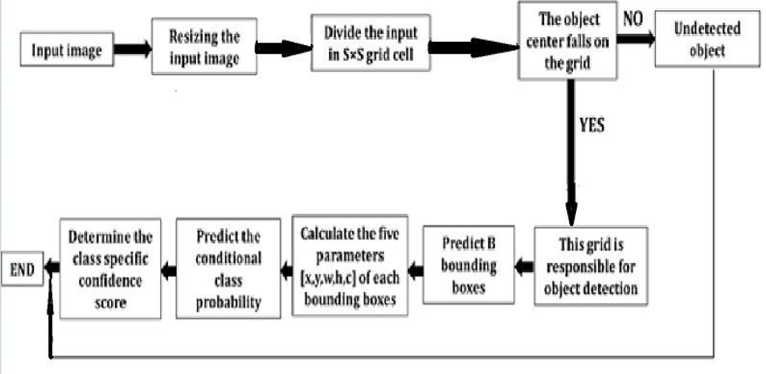
Figure 3.3: YOLO algorithm architecture
YOLO (You Only Look Once) showed a significant breakthrough in the field of object recognition and classification. The vehicle detection based on YOLO algorithm has better result which uses Convolution Neural Network (CNN) to extract features. Using CNN (convolutional neural network) for the object detection is to analyse the underlying feature characteristics and target objects in the images by the help of supervised learning.

The algorithm of YOLO (You Only Look Once) will be improving the accuracy of obtaining target object information from the image. YOLO is an end-to-end target object detection algorithm. The algorithm transforms the problem of target object detection into a problem of regression. YOLOv2 algorithm will be improving the object detection accuracy and efficiency. The improvements are done by adding batch normalization after every convolution layer. Performing multi-scale training and applying the K-means dimension clustering on the training set bounding box to which will be automatically determine the suitable priors.
The model based on YOLOv2 to detect number of vacant parking slots. YOLOv2 is trained on the combination of the COCO dataset and the ImageNet dataset to predict detections for object classes that do not have classified detection data. Anchor Boxes have been added for multi-class identification. For YOLO, detection is a simple regression problem which takes an input image and it divides each image into a grid of SxS. If the grid cell has the center of the object to be detected, the location information and category information of the object to be detected are predicted by the cell. Each cell predicts the conditional probability of categories C, bounding boxes B and their confidence scores. Each bounding box predicts information, including coordinates (x, y), width w and height h of the target and confidence, which are recorded as tx , ty, tw, th. Figure 3.3 shows the YOLO algorithm architecture, confidence score associated with each box helps in determining whether box has an object and if yes, then object class. YOLOv2 traverses the tree until certain threshold is reached and moves along the path with highest confidence score.

YOLO uses non maximum suppression method to filter the bounding box with lower threshold to get the best target prediction box. Although YOLO has faster detection speed than Faster R-CNN, its detection accuracy is lower. To solve this problem, YOLOv2 improves the network structure and replaces the full connection layer in the output with convolutional layer. The IoU indicates how accurate the model detects the target.

The basic idea of using convolutional neural network for vehicle detection is to analyse the underlying features and corresponding target tags of images by means of supervised learning. The weight of the trained network is loaded into the network, and the vehicle target in the image is identified by the forward reasoning of the network. The vehicle detection algorithm based on convolutional neural network has better robustness.

3.3 Summary
In this chapter, system design and implementation of this project is explained. The system module, design overview, implementation details where main packages, main user defined functions and algorithms of main module used in this project are explained.

CHAPTER 4
RESULT AND ANALYSIS
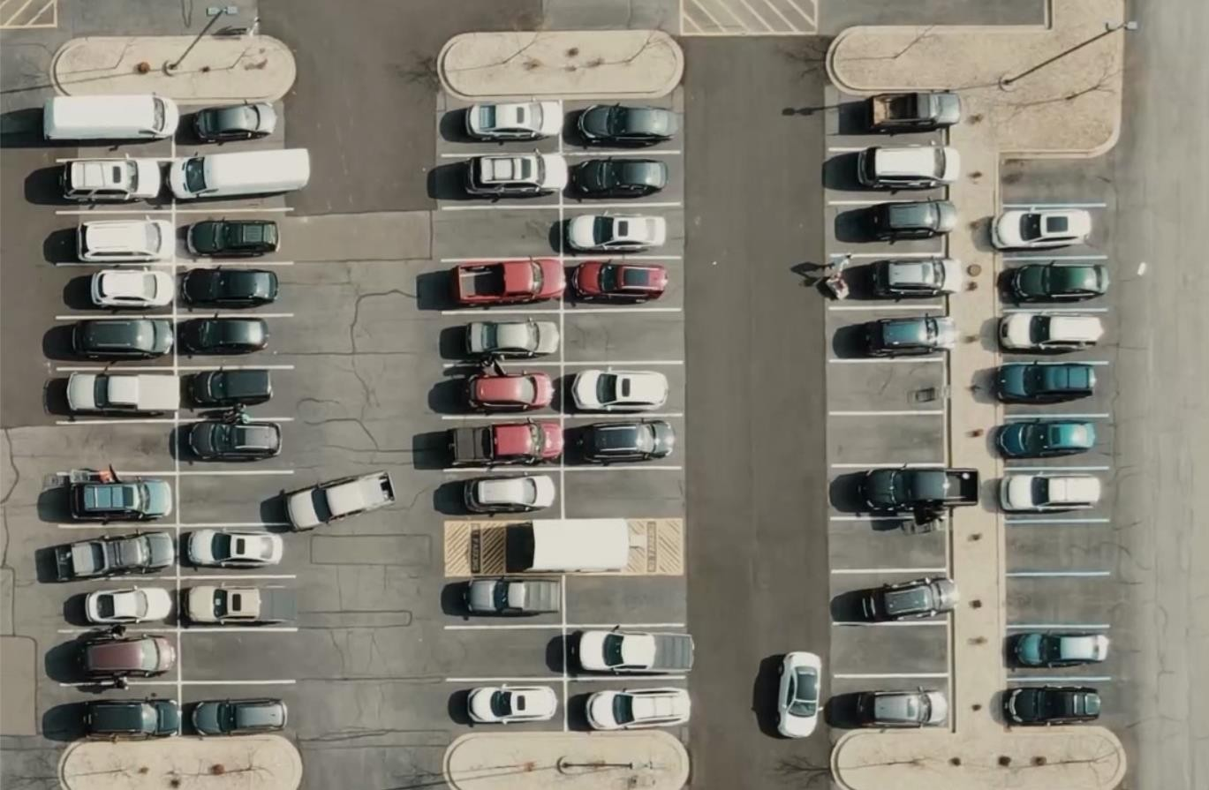
4.1 Snapshots of Results

Figure 4.1: Parking area image
Figure 4.1 shows, the parking area image where the system has been installed, which is used as input and is fed to the training model.
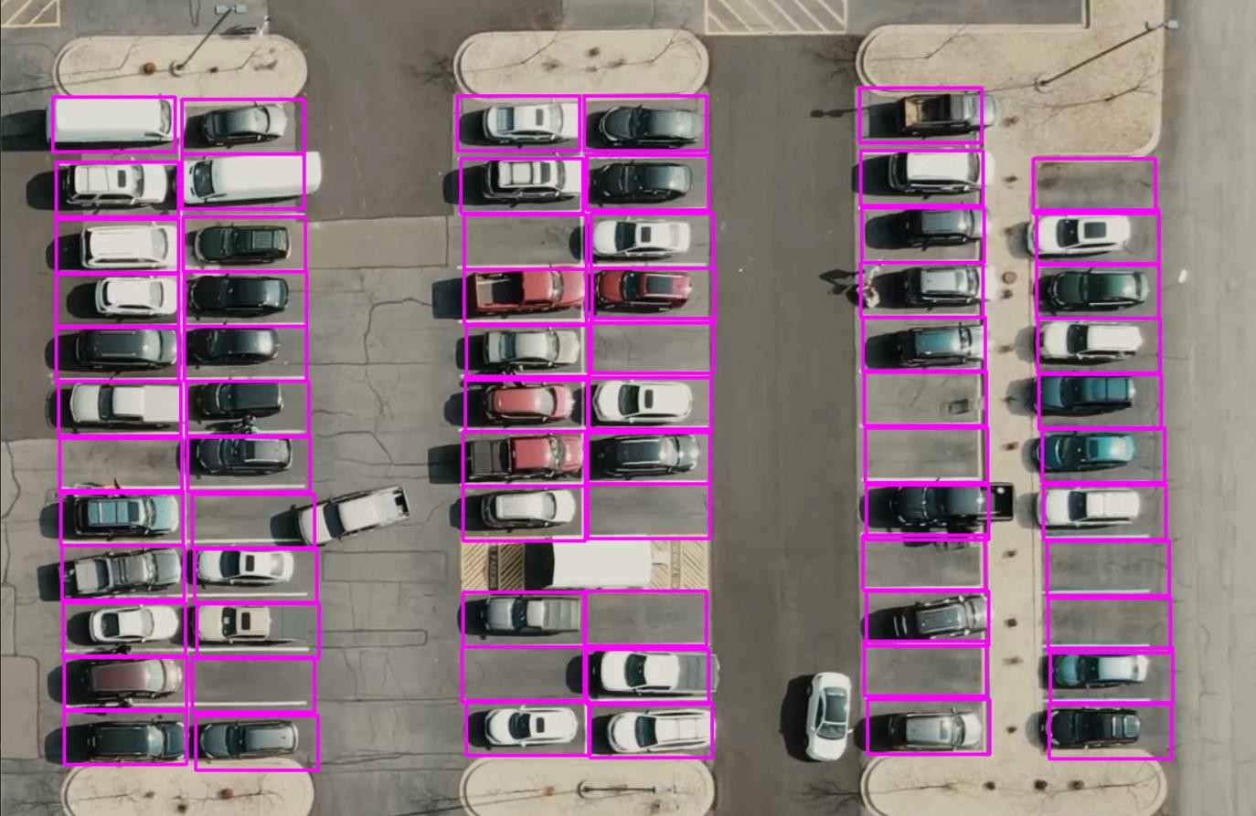

Figure 4.2: Parking area with marked slots
Figure 4.2 shows, the YOLO algorithm processing the input images and detects parking slots by drawing bounding boxes around the identified slots.
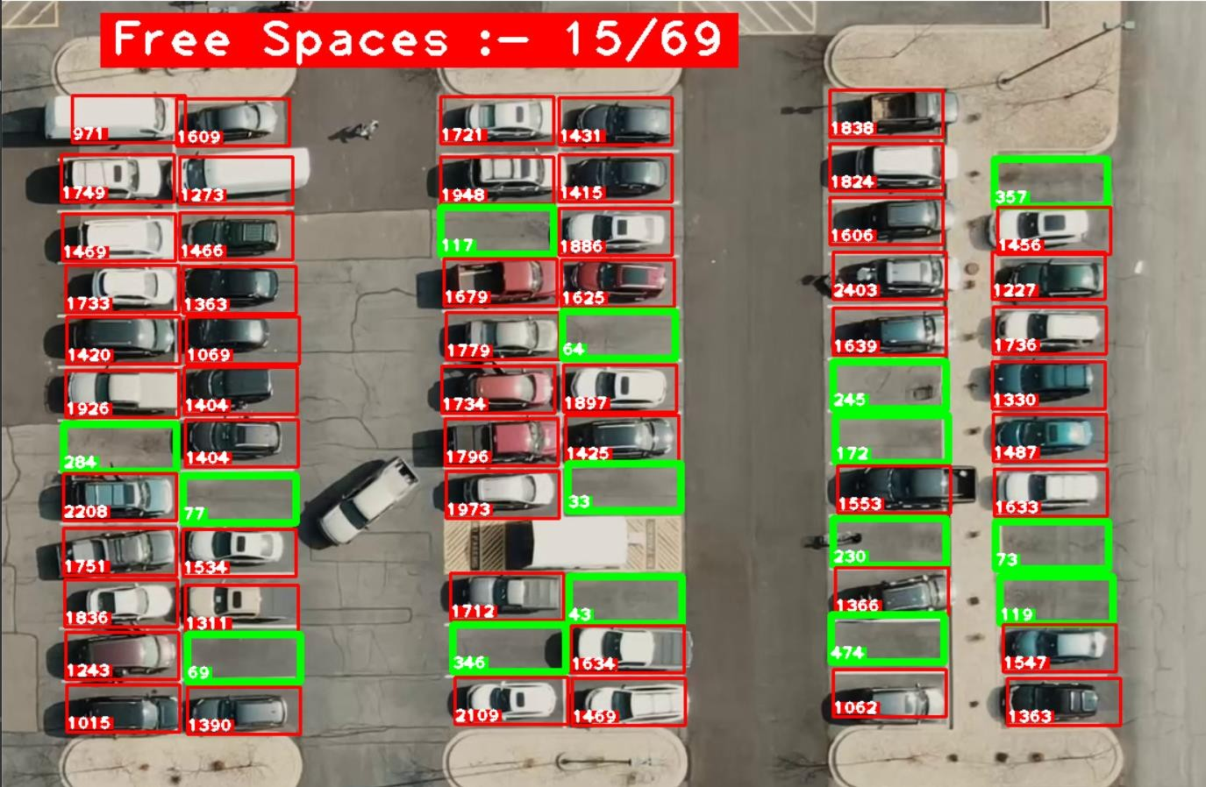
Figure 4.3: Output Live video with number of available parking slots and total parking slots is displayed as output.
Figure 4.3 shows, the output live video displayed on the monitor screen with number of available parking slots and total parking slots is displayed as output. The vacant slots are highlighted in green, while occupied ones in red.

Results obtained on varies parking slot images are mentioned in the below table 4.1. From the table its noted that, the model detects the free parking slot correctly.
Table 4.1: Output analysis
Parking slot images | Total no. of slot available | No. of slot filled | No. of slot empty | No. of empty slot detected by model
1 | 69 | 54 | 15 | 15
2 | 50 | 30 | 20 | 20
3 | 34 | 20 | 14 | 14
4 | 40 | 15 | 25 | 25

4.2 Summary
In this chapter, result and analysis of this project is explained along with the result snapshots.
CHAPTER 5

CONCLUSION AND FUTURE SCOPE

“Car Parking Slot Detection Using YOLO Algorithm” will be done by fixing a camera at the parking slot which will be capture the parking area images and using the YOLO algorithm, to detect and count the number of vehicles in each parking slot, by tracking the occupancy status of each slot over time, this provides real-time information to users about the availability of parking spaces. Having studied the different approaches and techniques in various survey papers as reference points, further work and study was conducted. After studying various machine learning algorithms, it was found that YOLO algorithm will produce more accurate result. Therefore, this algorithm will be used to develop the model to identify vacant and occupied parking slots and display number of vacant slots.

5.1 Future Scope
In the near future, advancements in technology will revolutionize the way of navigating urban landscapes with the development of a mobile application or website dedicated to effortlessly locating parking spaces for a variety of vehicles. This innovative platform will empower users to check the availability of parking spots in real-time without the need for physical visits to parking areas, saving time and reducing stress associated with finding parking. Through seamless integration of data from sensors, GPS technology, and user input, this solution will provide accurate and up-to-date information, enhancing the overall urban mobility experience and fostering more efficient use of parking infrastructure.

PUBLICATION
[1] Mohan H G, Deepthi B A, Dhanyatha B, Tanmayee Sharvani, Varshitha H G, "Car Parking Slot Detection Using Yolo Algorithm", International Journal of Scientific Research in Engineering and Management (IJSREM), Volume: 08 Issue: 03 | March - 2024 | DOI: 10.55041/IJSREM29713

REFERENCES

[1] Bandi Sairam and Gopi Krishna "Automated Vehicle Parking Slot Detection System Using Deep Learning " Proceedings of the Fourth International Conference on Computing Methodologies and Communication (ICCMC 2020) IEEE Xplore Part Number: CFP20K25-ART; ISBN:978-1-7281-4889-2

[2] Raj Patel and Praveen Meduri "Car Detection Based Algorithm for Automatic Parking Space Detection" 2020 19th IEEE International Conference on Machine Learning and Applications (ICMLA)

[3] Moran JU and Haibo LUO "A Simple and Efficient Network for Small Target Detection" 2020 19th IEEE International Conference on Machine Learning and Applications (ICMLA)

[4] Hanbo Zhoua and Wei Xiangc "Method for judging parking status based on yolov2 target detection algorithm" The 8th International Conference on Information Technology and Quantitative Management (ITQM 2020 & 2021)

[5] Aakash K. Shetty and Yashkumar J. Patel “A Review: Object Detection Models" 2021 6th International Conference for Convergence in Technology (I2CT) Pune, India. Apr 02-04, 2021

[6] Cui Gao and Qiang Cai "YOLOv4 Object Detection Algorithm with Efficient Channel Attention Mechanism" 2020 5th International Conference on Mechanical, Control and Computer Engineering (ICMCCE)

[7] Se-Ho Park and Hyoseok Yoon "An All-in-One Vehicle Type and License Plate Recognition System Using YOLOv4" 2022 by the authors. Licensee MDPI

[8] Jingyi Zhao, Zhanlin JI (Member, IEEE) and Ivan Ganchev (Senior Member, IEEE) “Improved Vision-Based Vehicle Detection and Classification by Optimized YOLOv4” 2021 19th IEEE International Conference on Machine Learning and Applications (ICMLA)

[9] Guan Sheng Wong, Kah Ong Michael Goh and Aznul Qalid Md. Sabri “Review of Vision-Based Deep Learning Parking Slot Detection on Surround View Images” 2023 by the authors. Licensee MDPI

[10] Upendra Suddamalla and Balaji Ravichandiran “Camera Based Parking Slot Detection For Autonomous Parking” (2020).

[11] Fatma M. Talaat and Hanaa Zain Eldin “An improved fire detection approach based on YOLO-v8 for smart cities” Neural Computing and Applications (2023)

[12] Nabin Sharma and Rathachai Chawuthai “Parking Time Violation Tracking Using YOLOv8 and Tracking Algorithms” 2023 by the authors. Licensee MDPI

[13] Xiangwu Ding and Ruidi Yang “Vehicle and Parking Space Detection Based on Improved YOLO Network Model” ICAITA 2019

[14] Daniel Padilla Carrasco and Domènec Puig “T-YOLO: Tiny Vehicle Detection Based on YOLO and Multi-Scale Convolutional Neural Networks” 2021 19th IEEE International Conference on Machine Learning and Applications (ICMLA)

[15] Mamoona Humayun and Marwah Khalid Alsadun " Traffic Management: Multi-Scale Vehicle Detection in Varying Weather Conditions Using YOLOv4 and Spatial Pyramid Pooling Network " 2022 by the authors. Licensee MDPI

